Causes of global blindness. An estimated 596 million people are visual impaired worldwide, and 43 million blind; 90% live in low- and middle-income countries. Infectious diseases like trachoma and onchocerciasis were once major causes of blindness in developing countries, but now the top causes of blindness worldwide are noncommunicable diseases: cataract, glaucoma, undercorrected refractive error, age-related macular degeneration, and diabetic retinopathy. The absolute numbers of people with visual impairment is rising as life expectancy rises throughout the globe. Key features of these diseases:
- Cataract
  - Pathophysiology: age-related clouding of the lens of the eye; vision loss is reversible
  - Risk factors: old age, trauma, diabetes, corticosteroids
  - Diagnosis: eye exam by an ophthalmologist, but initial screening can be done with a simple visual acuity test given the high prevalence, or by a trained worker using a simple penlight.
  - Treatment: The cataract can be removed with a relatively quick and inexpensive surgery though this requires an ophthalmologist. The threshold for operating differs throughout the world; rich countries operate on milder cataracts and poorer countries prioritize more advanced cataract.
- Glaucoma
  - Pathophysiology: age-related disease of the optic nerve, with two major varieties: open angle and angle closure glaucoma. Each can cause irreversible damage of the optic nerve, with resulting constriction of peripheral vision and ultimately blindness.
  - Risk factors:
    - Open angle glaucoma: high eye pressure, family history, African descent
    - Angle closure glaucoma: eye anatomy (narrow angles), East Asian descent
  - Diagnosis:
    - Open angle glaucoma: no single diagnostic test; eye pressure, visual field testing, and optic nerve imaging can be used.
    - Angle closure glaucoma: Imaging of “angle” on slit lamp exam (by ophthalmologist) or with a device to detect an eye at risk of acute angle closure; same tests as open angle glaucoma for eyes with chronic angle closure glaucoma
  - Treatment:
    - Open angle glaucoma: Eyedrops, essentially for the rest of the patient’s life, or a one-time surgery (but the surgery has relatively high complication rates). The goal is to lower the eye pressure and prevent further damage.
    - Angle closure glaucoma: Laser to prevent acute angle closure; eye drops and surgery for chronic form of disease.
- Refractive error:
  - Pathophysiology: light not focused onto the retina correctly; broadly categorized as myopia (i.e., near sightedness), hyperopia (i.e., far-sightedness), astigmatism, and presbyopia (need for reading glasses later in life). Myopia usually caused by lengthening of eyeball; this can progress to cause irreversible retinal damage. Otherwise, typically reversible vision loss.
  - Risk factors: family history; myopia more common in East Asians; usually presents in childhood; near work (e.g., reading); increasing prevalence in recent years
  - Diagnosis: Refraction, usually by a human. Autorefractors are available to get a ballpark refraction, but usually this is fine-tuned by a human
  - Treatment: Eyeglasses or contact lenses. Children with myopia are often treated with atropine eye drops or contact lenses to prevent progression.
- Diabetic retinopathy (DR):
  - Pathophysiology: bleeding and swelling of retina; longstanding disease causes irreversible vision loss.
  - Risk factors: uncontrolled diabetes
  - Diagnosis: dilated eye exam or by retinal imaging
  - Treatment: eye injections of a relatively expensive medication, or laser treatments (in addition to better control of blood sugar)
- Age-related macular degeneration (AMD):
  - Pathophysiology: retinal atrophy (“dry AMD”) and/or growth of abnormal blood vessels in retina (“wet AMD”); causes progressive irreversible vision loss
  - Risk factors: old age, Caucasian descent
  - Diagnosis: dilated eye exam or by retinal imaging
  - Treatment: eye injections of a relatively expensive medication for wet AMD can reverse some vision loss; oral vitamins for dry AMD can prevent progression, but marginally effective.

Diagnostic equipment: the following are the primary ways these eye diseases are diagnosed:
- Slit lamp: the main examination device that an ophthalmologist uses; can be used to diagnose all eye disease. Costs tens of thousands of dollars; only present at eye hospitals.
- Visual acuity: the “E” chart; this is not specific but does identify cases that should be assessed further; most people in resource-limited settings with poor vision will have cataract. Costs dollars; does not require an experienced technician.
- Pinhole occluder: cheap screening test for refractive error; if vision improves with pinhole this suggests refractive error as cause of vision loss
- Autorefractor: provides estimate of the glasses prescription; available in portable models for ~$5000, though usually needs manual refinement.
- Refraction set: a set of lenses a human refractionist uses to perform a refraction; ~$200.
- Penlight: for a simple anterior segment exam in the field; can identify cataract; costs dollars.
- Fundus camera: relatively portable models are available to take photos through a dilated or undilated pupil; if a patient has a cataract then the undilated photos can be difficult or impossible. Fundus images can be used to detect glaucoma, DR, and AMD. Costs on the order of $5 to 10,000.
- Optical coherence tomography (OCT): not very portable (more delicate than a fundus camera); can be used to image the anterior segment (for angle closure glaucoma), optic nerve (glaucoma), and retina (DR/AMD). Unlike fundus photos, OCT can usually capture an image even if the patient has a small pupils or cataract, so dilation not a requirement. Costs on the order of $25,000.
- Tonometry: a test for eye pressure; this is built into the slit lamp. Portable versions are available for ~$5000; used as a test for glaucoma though not very sensitive.
- Perimetry: a test for the visual field for glaucoma. Portable perimeters are available; tests require participation from patient and take 1-2 minutes per eye. False positives are common, especially the first time taking the test. Patients usually get better the more times they take it. Costs around $5 to 10,000 for a portable machine, more for a more reliable hospital-based machine.

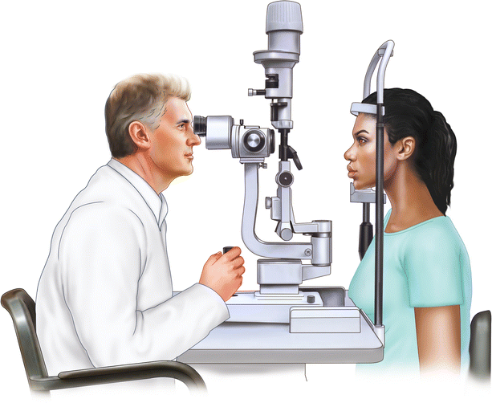  Slit lamp biomicroscope | 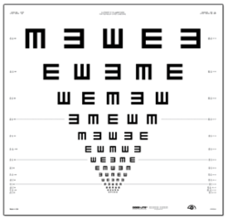  Visual acuity chart | 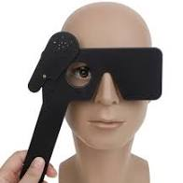  Pinhole occluder
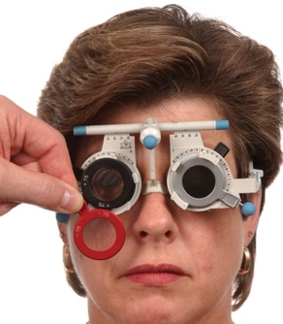  Manual refraction, test lenses | 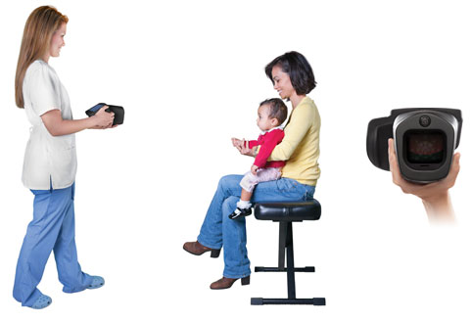  Autorefractor | 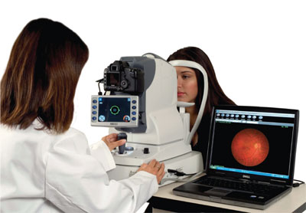  Tabletop fundus camera
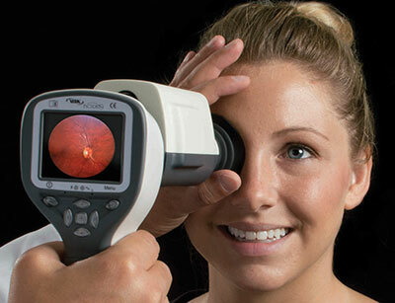  Handheld fundus camera | 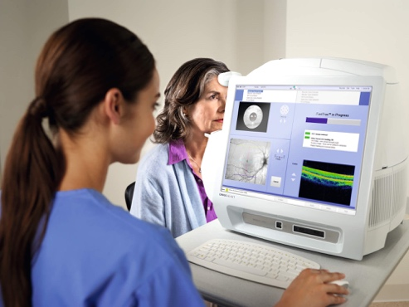  Optical coherence tomography | 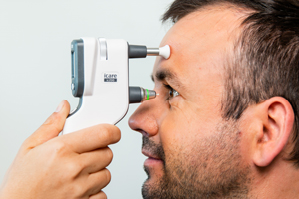  Portable tonometer
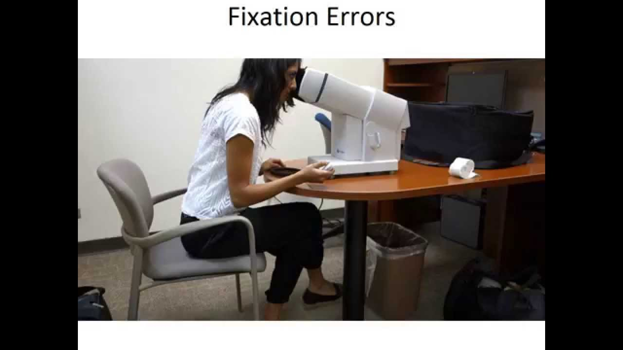  Portable perimeter | 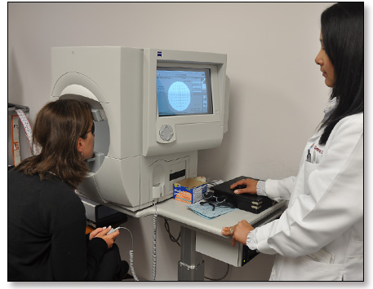  Non-portable perimeter

Treatment equipment: The following are the basic requirements for treating these diseases:
- Operating microscope: for cataract surgery, glaucoma surgery; typically not very portable; requires skilled ophthalmologist to operate; expensive
- Intraocular lens implants: when a cataract is removed, an intraocular lens implant is inserted to help focus light to the retina. High quality lenses can be purchased inexpensively from facilities in India and elsewhere.
- Eyeglasses: a lens grinding machine and other equipment is needed for production of eyeglasses that have a custom prescription (i.e., the routine situation); this is done by skilled non-ophthalmologist personnel; usually at an optical shop but can theoretically be done in in the community. Note also that some programs use ready-to-use spectacles that are not customized to the patient but close enough to improve the vision; in this case the eyeglasses can simply be purchased.
- Eyedrops for glaucoma are widely available and not very expensive, though need to be taken for the rest of the patient’s life. Atropine drops for myopia are widely available, and would be administered for several years.
- Intraocular injections can be used for AMD and DR; these are relatively expensive, often not available in resource-limited settings, and require an ophthalmologist to administer.
- YAG laser: for laser procedures to prevent angle closure; typically not very portable; requires skilled ophthalmologist to operate; expensive
- Argon laser: for laser procedures for diabetic retinopathy; typically not very portable; requires skilled ophthalmologist to operate; expensive

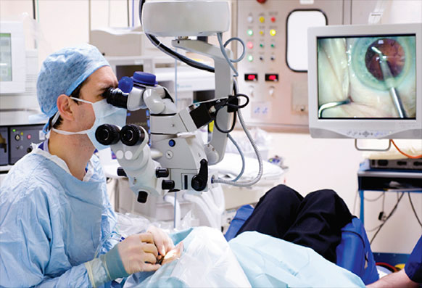  Operating microscope | 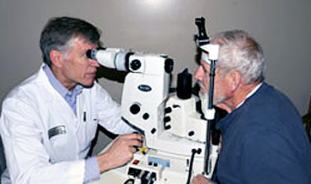  YAG laser | 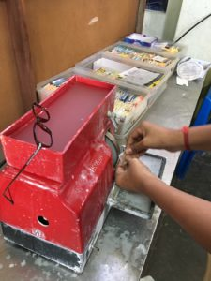  Lens grinder for eyeglasses

Screening. Screening for a disease is recommended if (a) the disease is relatively prevalent, (b) has an asymptomatic phase, (c) has a sensitive and specific diagnostic test, (d) has effective treatments to prevent progression of disease, and (d) diagnosis/management is cost-effective.

Watch: Aravind Eye Hospital is one of the most famous eye hospitals in the world. This 15-minute documentary introduces Aravind: https://www.youtube.com/watch?v=Wfsrg7aait8

Read: A Lancet Global Health Commission did a nice job of outlining the current state of global eye health. Please read sections 1 and 2 closely, as well as Figure 8. The whole article is quite informative but if short on time and skimming parts of it, you might read more closely the sections of most interest:
- Panel 2: changing epidemiology of eye disease
- (Section 6): Delivering integrated people-centered eye care
- (Section 6): Human resources for eye health
- (Section 6): Innovating delivery: technology to support eye health
- (Section 6): Sustainable financing for eye health
- (Section 6): Measuring progress in eye health
- (Section 6): Progress towards universal eye health coverage
- (Section 6): Improving quality of eye care
- (Section 6): Increasing access and equity in eye care
- (Section 6): Political prioritization of global eye health

Task: We will break into 3 small groups. Imagine that you are working for the Ministry of Health in Nepal and have a fixed budget. Nepal consists of 3 distinct regions: the mountains, which are sparsely populated and very difficult to reach, the terai, which is the low-lying near India that is densely populated and relatively easy to reach, and the hills, which are in-between. Note that the Ministry must serve all these regions but that approaches may differ.

Each group will tackle a category of eye disease: cataract, refractive error, and glaucoma/diabetic retinopathy (lumped together since these diseases require examination of the back of the eye with more advanced equipment). We will discuss how you would approach each disease in order to reduce visual impairment from the disease, and ultimately whether it makes sense to spend the Ministry’s resources on the particular disease. The approach could differ for the 3 diseases, given different prevalence of disease, affected populations, costs of diagnostic tests, requirements for skilled personnel, and need for follow-up care. The example matrix below will help you consider some of the major issues, and the readings can provide insights for other issues to consider. We will come together for the final 15 minutes to discuss the differences in approach for each of these categories of disease.

Considerations for a health program to reduce blindness due to macular degeneration
 | Age-related macular degeneration
Affected population
Age | Older people, mobility issues, need to be accompanied if traveling, might have difficulty understanding tests involving technology; given population pyramid in Nepal might not be a large cause of blindness
Urban/rural | AMD more common in urban areas (life expectancy greater in urban areas)
Race | More common in Caucasians, might not be a large cause of blindness in Nepal
Diagnosis
Barriers to diagnosis | Asymptomatic early, lack of awareness among population, requires eye exam by specialist or an expensive machine (fundus photo, OCT); eye exam should ideally be done with a dilated pupil (which may reduce participation)
Case detection vs screening | Both: want to detect active cases because treatment can improve vision, but if disease is active for too long then causes irreversible vision loss, so need to pick up cases early
Type of facility | Eye hospital, mobile van that can accommodate equipment; this difficult in the mountains
Other clinic/NGO partners | Geriatric clinics?
Equipment needed | Ophthalmoscope (if ophthalmologist examining), or fundus camera / OCT if a technician is screening
Skilled workforce needed | Ophthalmologist or technician to operate diagnostic equipment and someone to interpret the imaging
Telemedicine | Portable cameras can be used, though how would images be graded? At the point-of-care? At a reading center? Internet connection could likely handle transfer of photos to a reading center in the terai, but not in the mountains.
Treatment
Barriers to treatment | High cost of eye injections, requires experienced ophthalmologist
Availability | Medication available at eye hospitals in the major cities only
Type of facility | Eye hospital
Costs | High cost for medication itself
Need for follow-up visits | Often requires repeated injections every 3 months

